HOTELS FOR WORLD CUP IN QATAR NEED REALLY TO GO THRU LOCAL DMC AS GOVERNMENT HAS HOLD ON MOST ROOMS

THERE IS A FIVE STAR FLOATING HOTEL TO BE FINISHED BY THE WORLD CUP

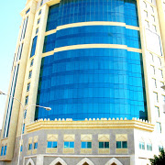

[Grand Hyatt Doha Hotel & Villa | 5 Star Luxury Hotel | hyatt.com‎](https://www.googleadservices.com/pagead/aclk?sa=L&ai=DChcSEwjBhtz-6tHeAhWHbH4KHTswDe4YABAAGgJwYw&ohost=www.google.com&cid=CAESEeD2z2FhBZwAVSt139M_mh55&sig=AOD64_1gWj9l2O--9cYM8fIOD5-SlvKX4Q&q=&ved=2ahUKEwjCl9X-6tHeAhXGr1QKHRr2C0IQ0Qx6BAgKEAE&adurl=)

[Addoha.grand.hyatt.com/Save-With-Hyatt/Luxury-Hotel‎](https://www.googleadservices.com/pagead/aclk?sa=L&ai=DChcSEwjBhtz-6tHeAhWHbH4KHTswDe4YABAAGgJwYw&ohost=www.google.com&cid=CAESEeD2z2FhBZwAVSt139M_mh55&sig=AOD64_1gWj9l2O--9cYM8fIOD5-SlvKX4Q&q=&ved=2ahUKEwjCl9X-6tHeAhXGr1QKHRr2C0IQ0Qx6BAgKEAE&adurl=)

[Rating](https://www.google.com/shopping/seller?q=hyatt.com&hl=en&sa=X&ved=2ahUKEwjCl9X-6tHeAhXGr1QKHRr2C0IQwQZ6BAgKEAQ) for hyatt.com: 5.0 - 573 reviews

Close to Airport, and steps away from the City’s Financial & Commercial Centre. Free Wi-Fi Service. No Booking Fees. Best Rate Guaranteed. Unmatched Luxury. Amenities: Largest **Hotel** Beach, Award Winning Spa, Near Golf Club, Best Price Guaranteed, Next to a Luxury Mall, Complimentary Wi-Fi.

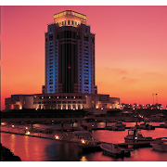

### [The Ritz-Carlton, Doha | Sharq Village & Spa‎](http://www.ritzcarlton.com/qatar)

[Adwww.ritzcarlton.com/Doha‎](http://www.ritzcarlton.com/qatar)

[Rating](https://www.google.com/shopping/seller?q=ritzcarlton.com&hl=en&sa=X&ved=2ahUKEwjCl9X-6tHeAhXGr1QKHRr2C0IQwQZ6BAgQEAQ) for ritzcarlton.com: 5.0 - 198 reviews

Rewards Members Enjoy Complimentary In-Room WiFi. Enroll & Reserve Now. The Ritz-Carlton Rewards. Arabian Gulf & City Views. Island Resort. Gold Standard Service. Amenities: World-Class Spa, Indoor/Outdoor Pools, Private Balconies, Ritz Kids

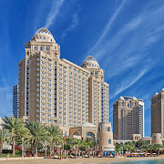

Four Seasons Hotel Doha

4.6  (1,229) · 5-star hotel

Refined rooms & posh suites with city or sea views, plus multiple restaurants, 5 pools & a spa.



Grand Regal Hotel

3.9  (577) · 5-star hotel

Posh quarters in an upscale hotel offering dining, a spa, a nightclub & an outdoor pool

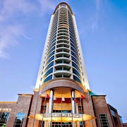

Hilton Doha

4.3  (2,113) · 5-star hotel

Upscale quarters in a modern hotel with 3 restaurants, a pool & a private beach, plus a spa.

Free Wi-Fi

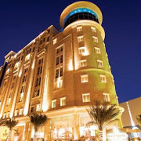

Millennium Hotel Doha

4.3  (734) · 5-star hotel

Modern rooms in a polished hotel offering a restaurant, a gym, an indoor pool & a spa.

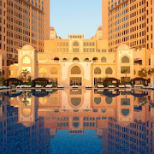

The St. Regis Doha

4.6  (1,792) · 5-star hotel

Bright rooms & suites in an elegant hotel offering 11 dining options, a pool & a private beach.

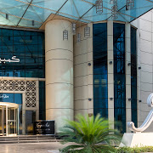

Kempinski Residences & Suites, Doha

4.5  (435) · 5-star hotel

Sophisticated suites, some with 3-stories, in an elegant hotel with 2 pools, a spa & a gym

FOUR STAR HOTELS

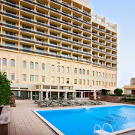

Mercure Grand Hotel Doha City Centre

3.9  (704) · 4-star hotel

Modern hotel offering modest rooms & suites, plus an outdoor pool, a gym & a French cafe.

Free Wi-FiFree breakfast

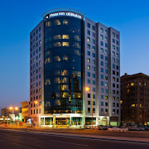

Plaza Inn Hotel

3.8  (489) · 4-star hotel

Warmly styled rooms & suites in a modern hotel with dining, a gym & a rooftop pool.

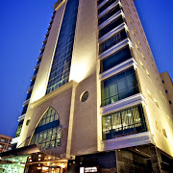

Century Hotel Doha

4.0  (532) · 4-star hotel

Rooms & suites with contemporary-chic decor, plus a free breakfast buffet, a gym & a spa area.

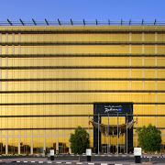

Radisson Blu Hotel Doha

4.3  (2,663) · 4-star hotel

Sophisticated hotel offering 12 restaurants & 7 bars, plus an outdoor pool, tennis & 2 gyms.

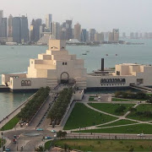

Horizon Manor Hotel

4.0  (995) · 4-star hotel

Elegant high-rise hotel featuring a rooftop pool with a cafe/shisha lounge, plus a gym & a pub.

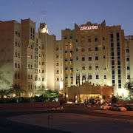

Mövenpick Hotel Doha

4.1  (688) · 4-star hotel

Elegant rooms & suites overlooking the Corniche, plus casual dining, 2 bars & a pool.

Free Wi-Fi

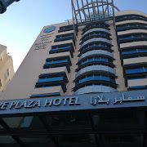

Sapphire Plaza Hotel

4.0  (727) · 4-star hotel

Refined hotel with warm rooms & suites, plus an international restaurant, indoor pools & a gym.

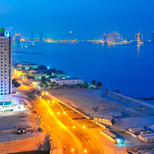

Retaj Al Rayyan Hotel

4.1  (966) · 4-star hotel

Bright rooms with sea views, plus a casual cafe, an international restaurant & an indoor pool.